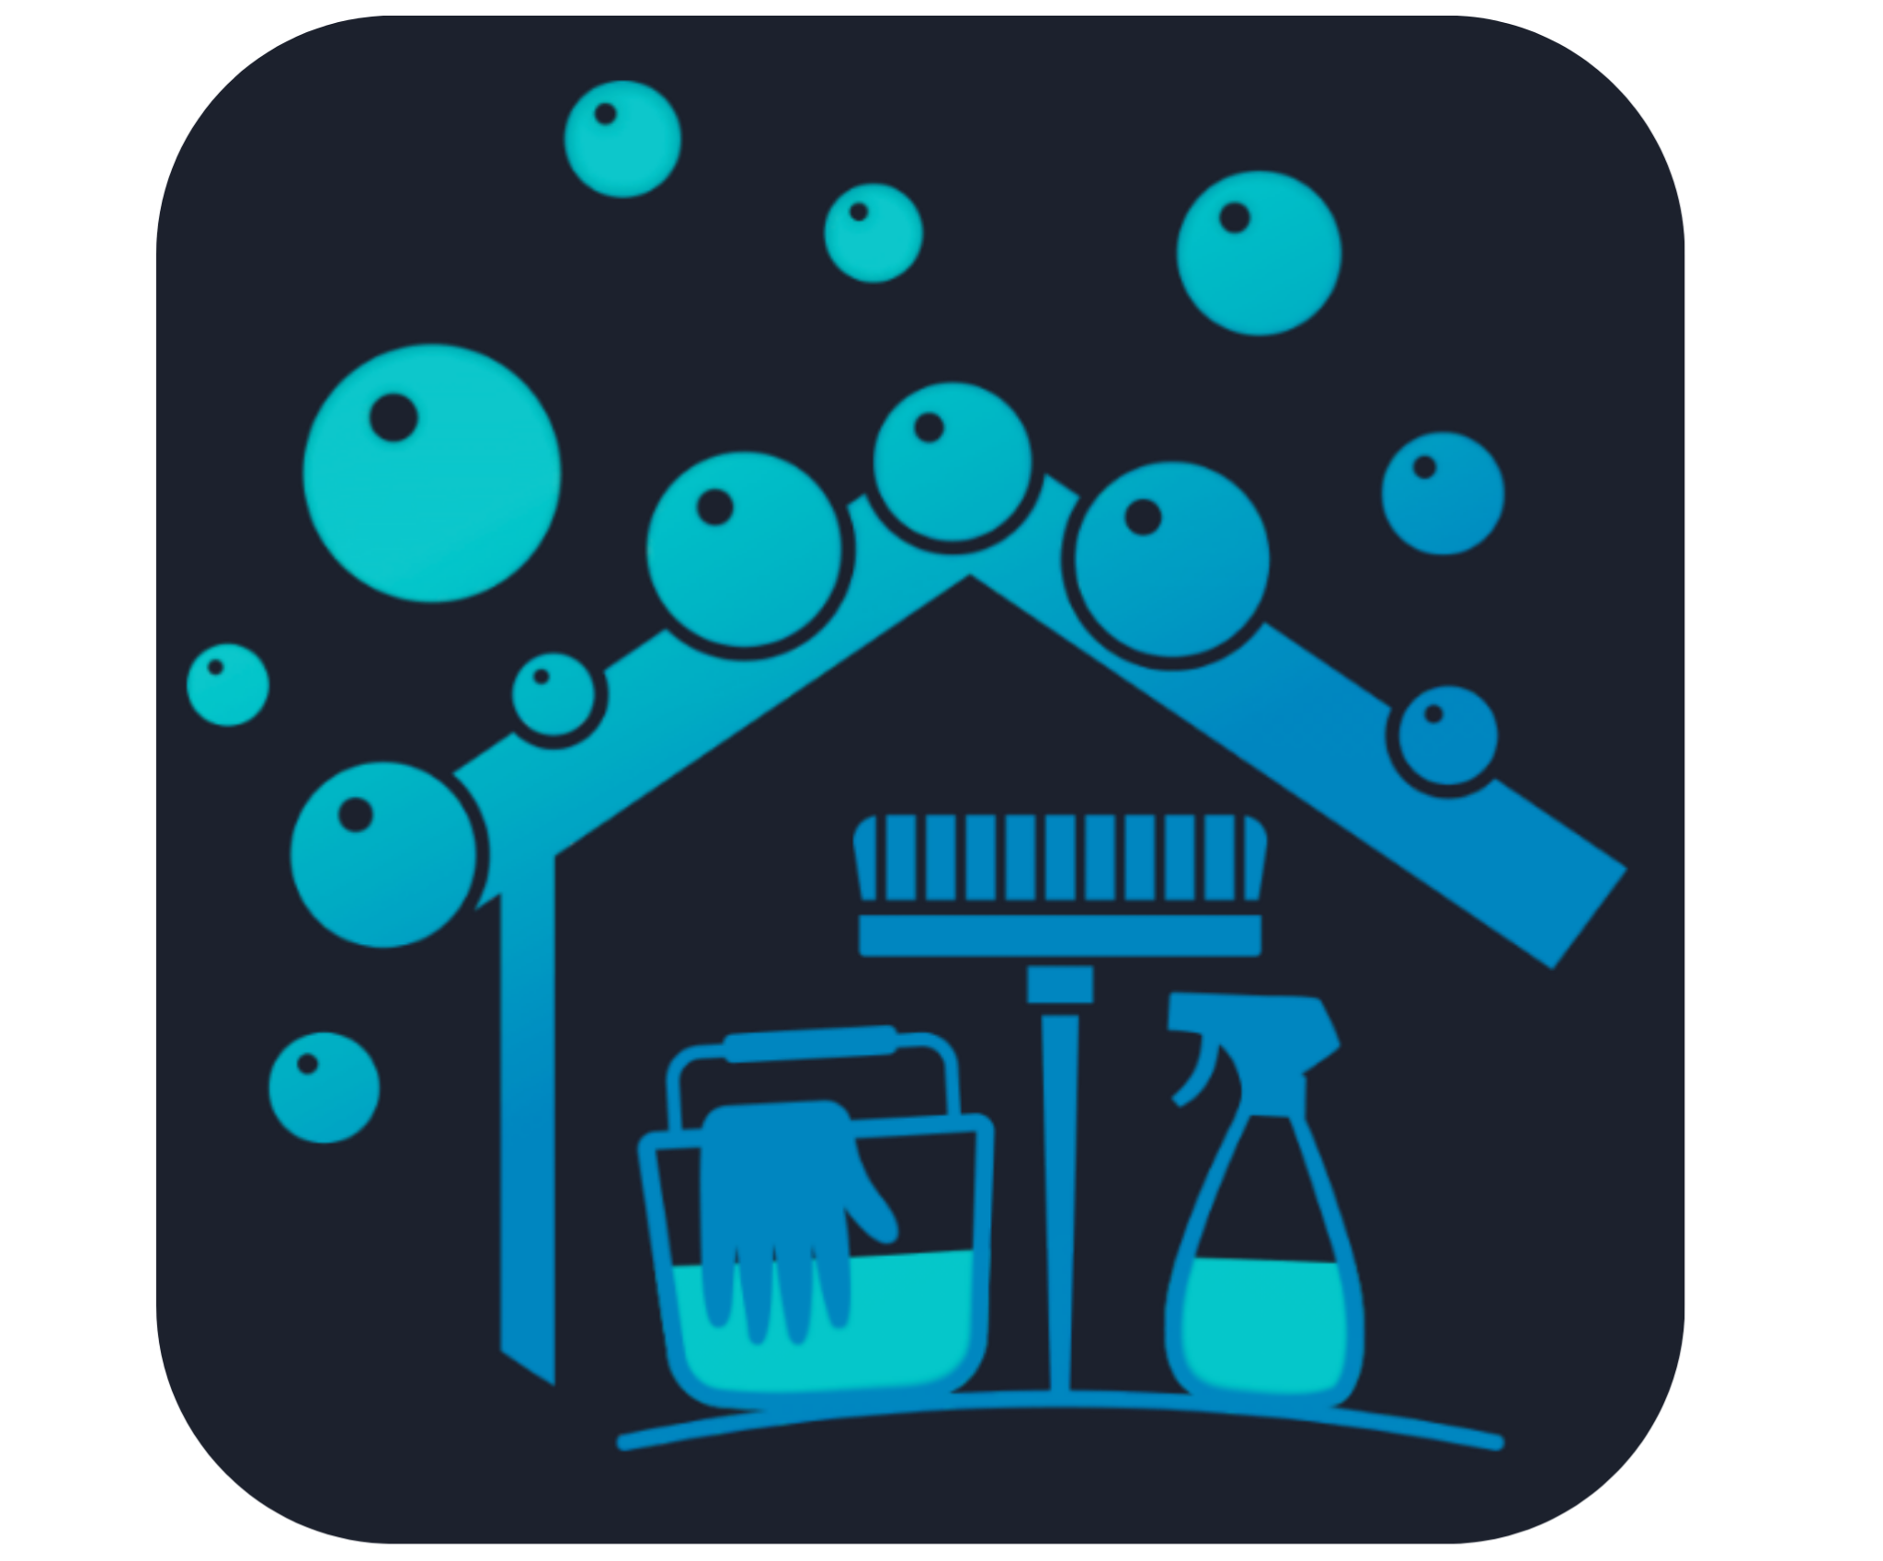[**Cleanova Property services list**](https://cleanovapropertyservices.co.nz/)****

**\*Contact details can be found in the PDF's conclusion**

* **Commercial And Office Cleaning**
  + **Office & Workplace cleaning**

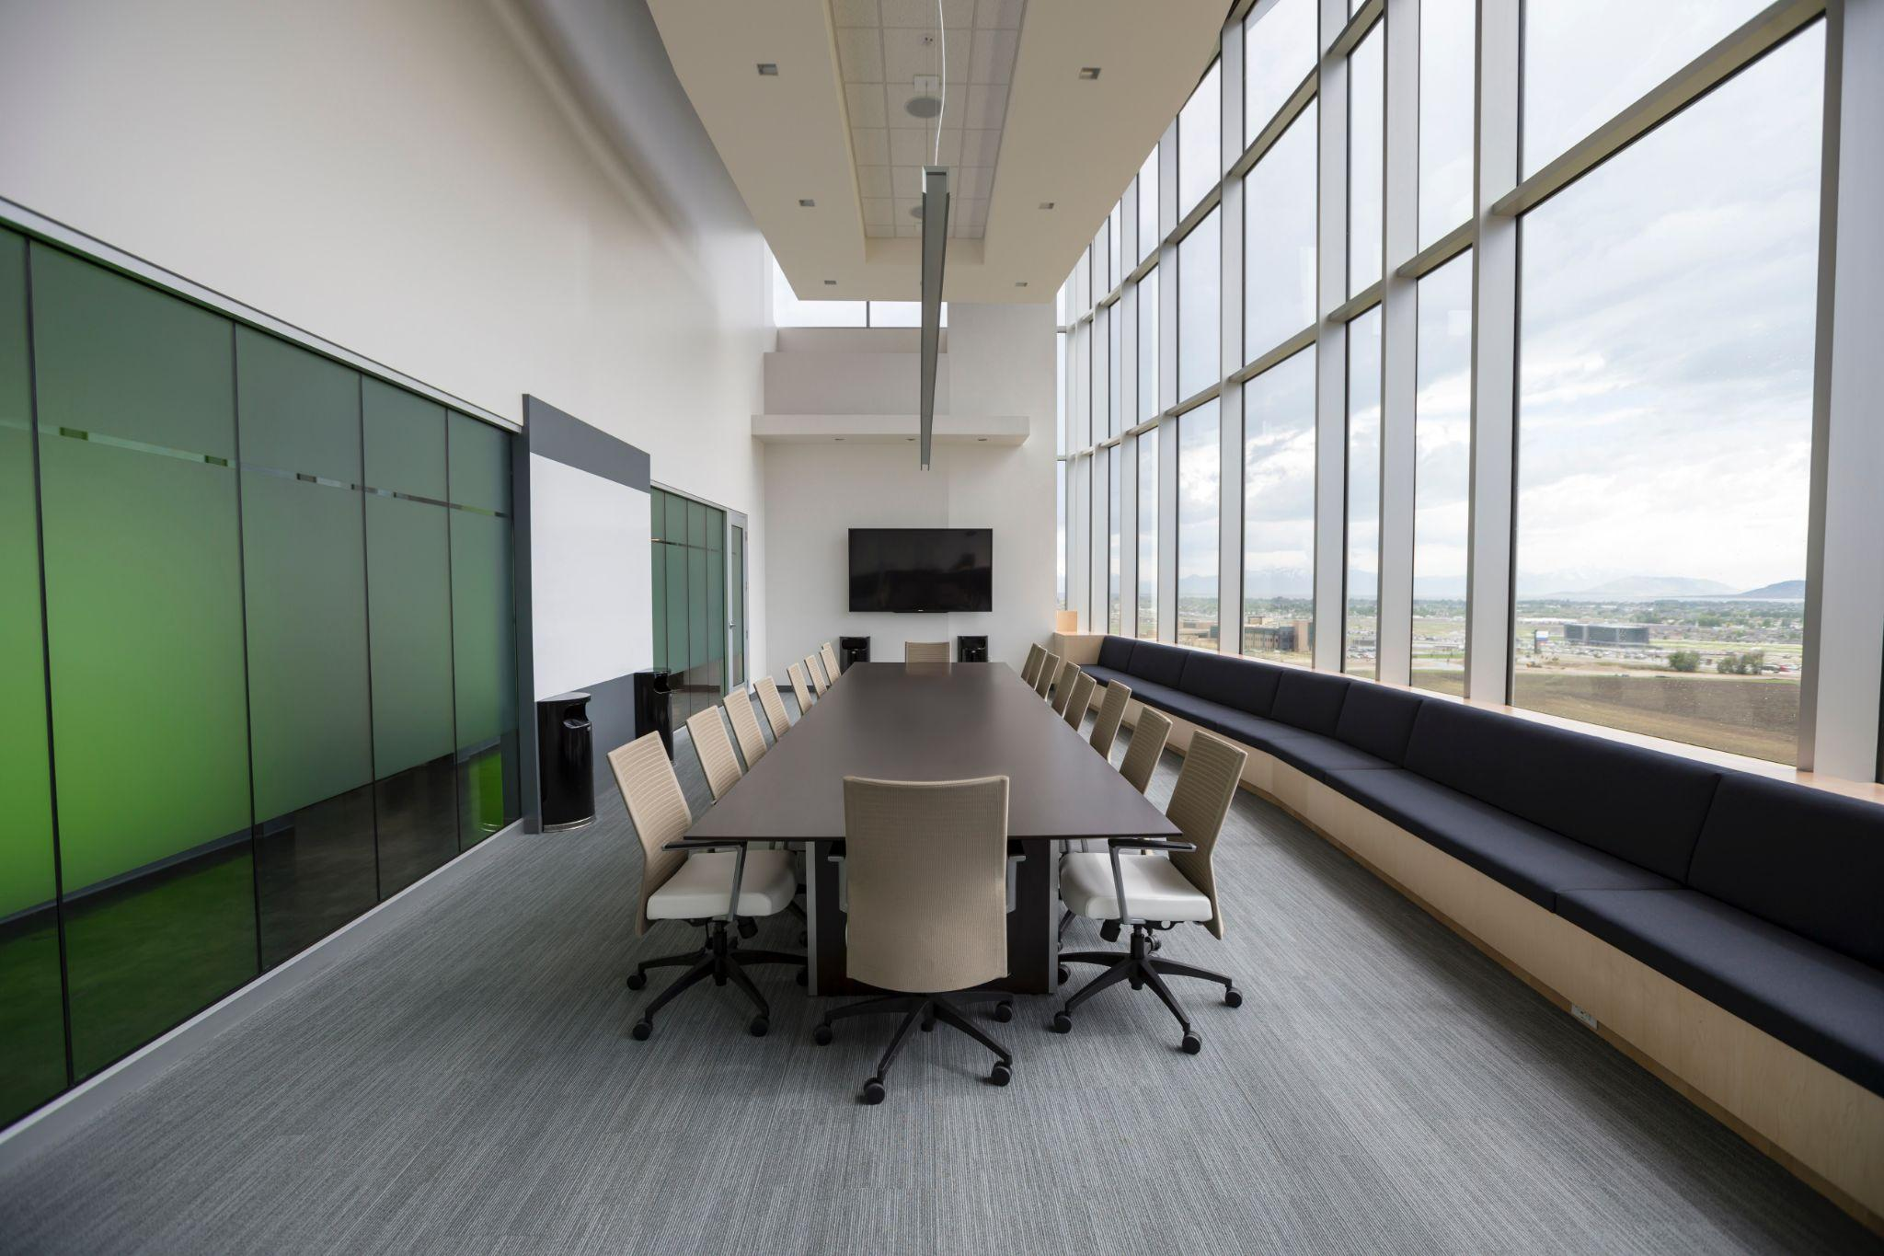

Maintain a professional and productive workspace with our comprehensive office cleaning solutions. We meticulously scrub and dust every nook and corner, ensuring a pristine environment that boosts employee morale and leaves a lasting impression on visitors.

* + **Sanitation of Shared Spaces**

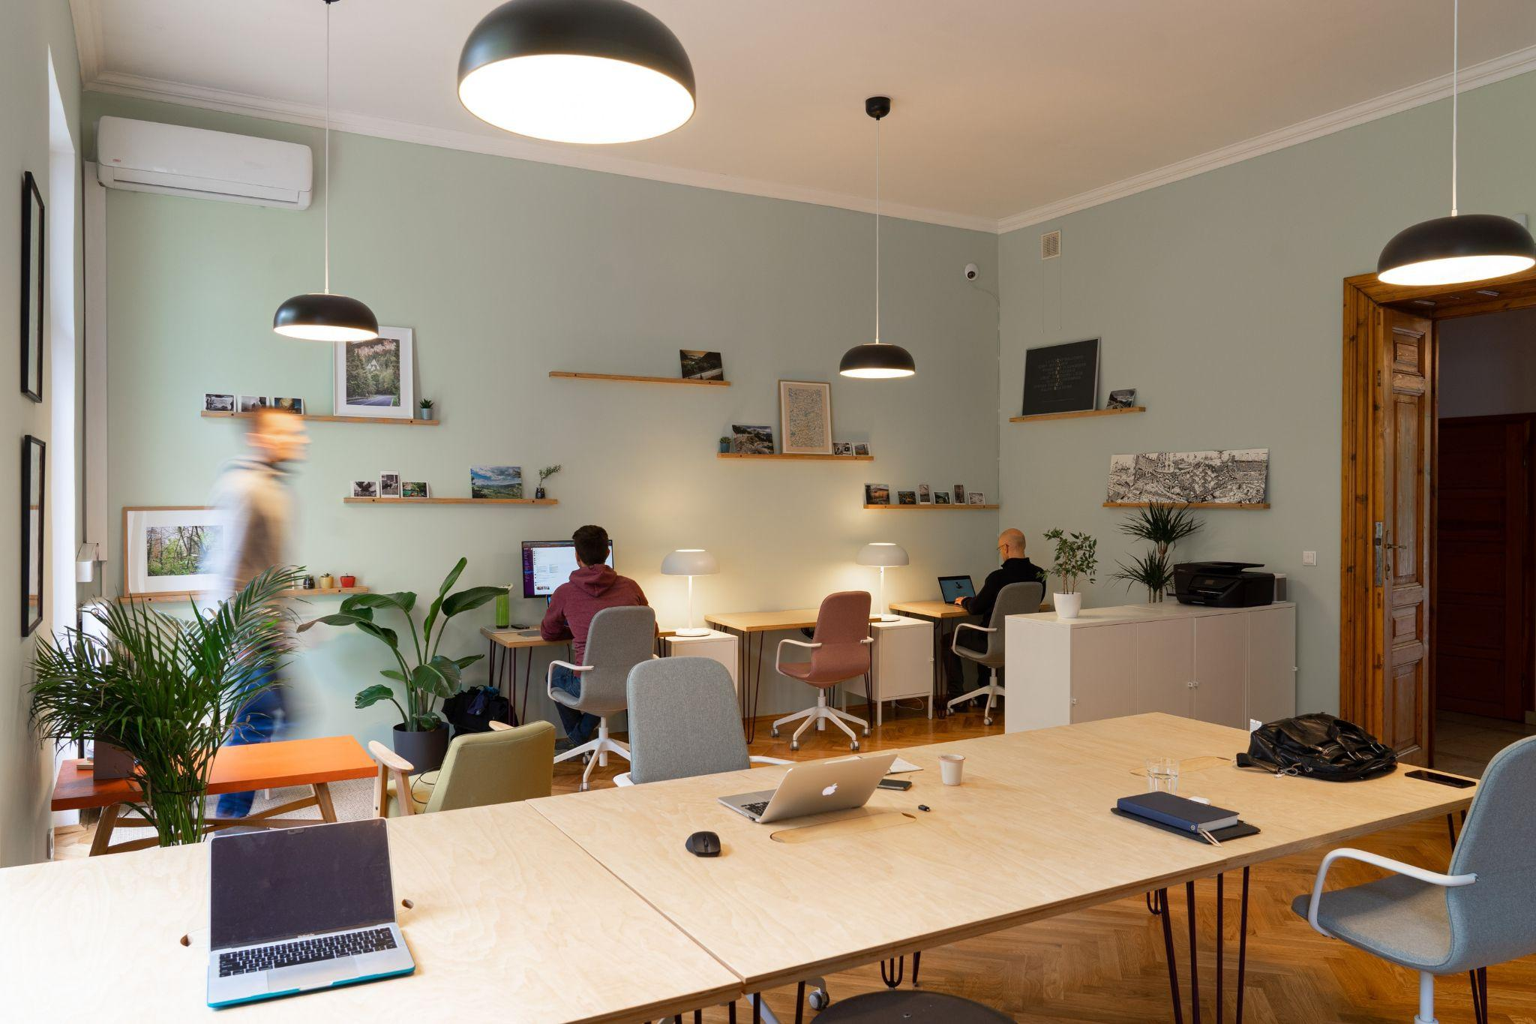

High-traffic shared spaces can become a breeding ground for germs and bacteria. We specialize in the sanitation of these areas, employing advanced cleaning methods to eliminate pathogens and ensure a hygienic environment for all users.

* + **Post-Construction Cleanup**

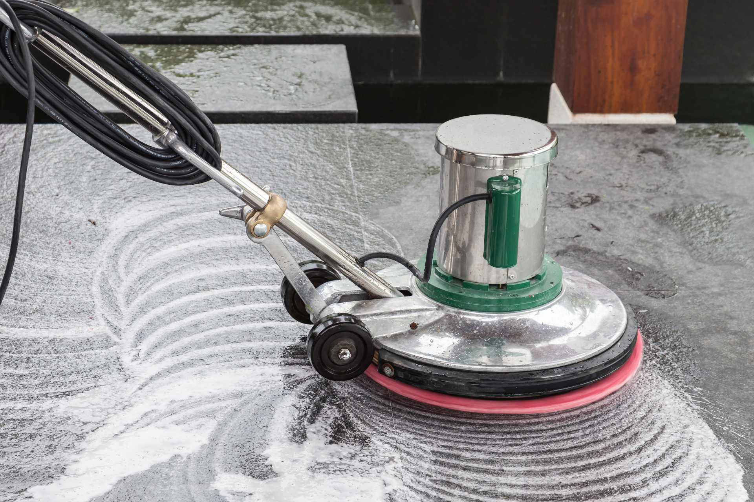

Transition seamlessly from construction to occupancy with our post-construction cleanup services. We swiftly remove debris, dust, and residues, presenting you with a spotless space that’s ready for its new purpose.

* + **Cleaning Services for Educational Institutions**



Institutions of learning deserve a clean slate every day. We provide specialized cleaning services for educational facilities, ensuring a safe and healthy environment where students and staff can thrive.

* + **Cleaning Services for Malls and Stores**

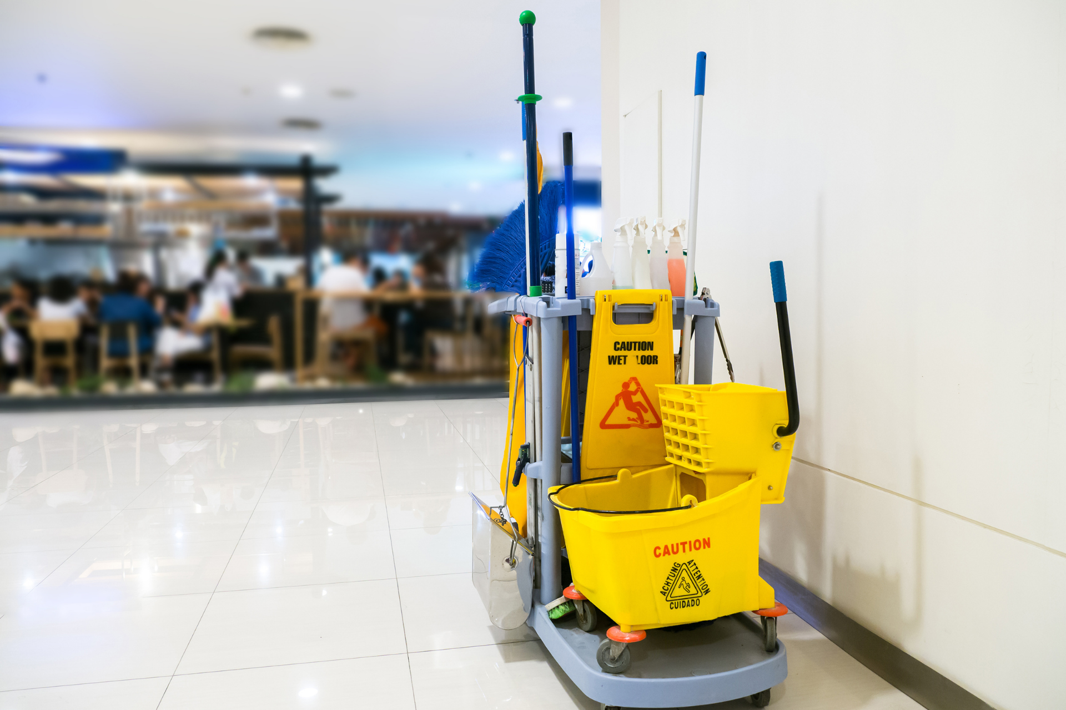

Shopping experiences are elevated in clean environments. Our cleaning solutions for malls and stores ensure shiny floors, dust-free surfaces, and a pleasant ambiance that invites and retains customers.

* + **Interior & Exterior Window Cleaning**

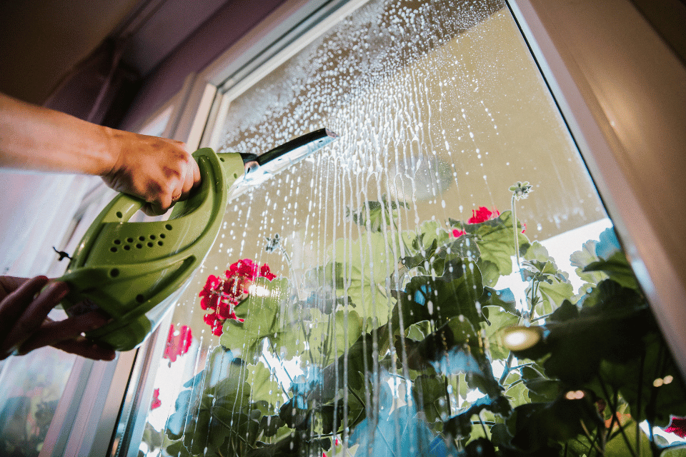

Let the light shine through spotless windows. Our transparent surface sanitation services guarantee streak-free and germ-free windows that not only elevate aesthetics but also promise a safer touch point for users.

* **Residential Cleaning**
  + **Lease Property Sanitation**

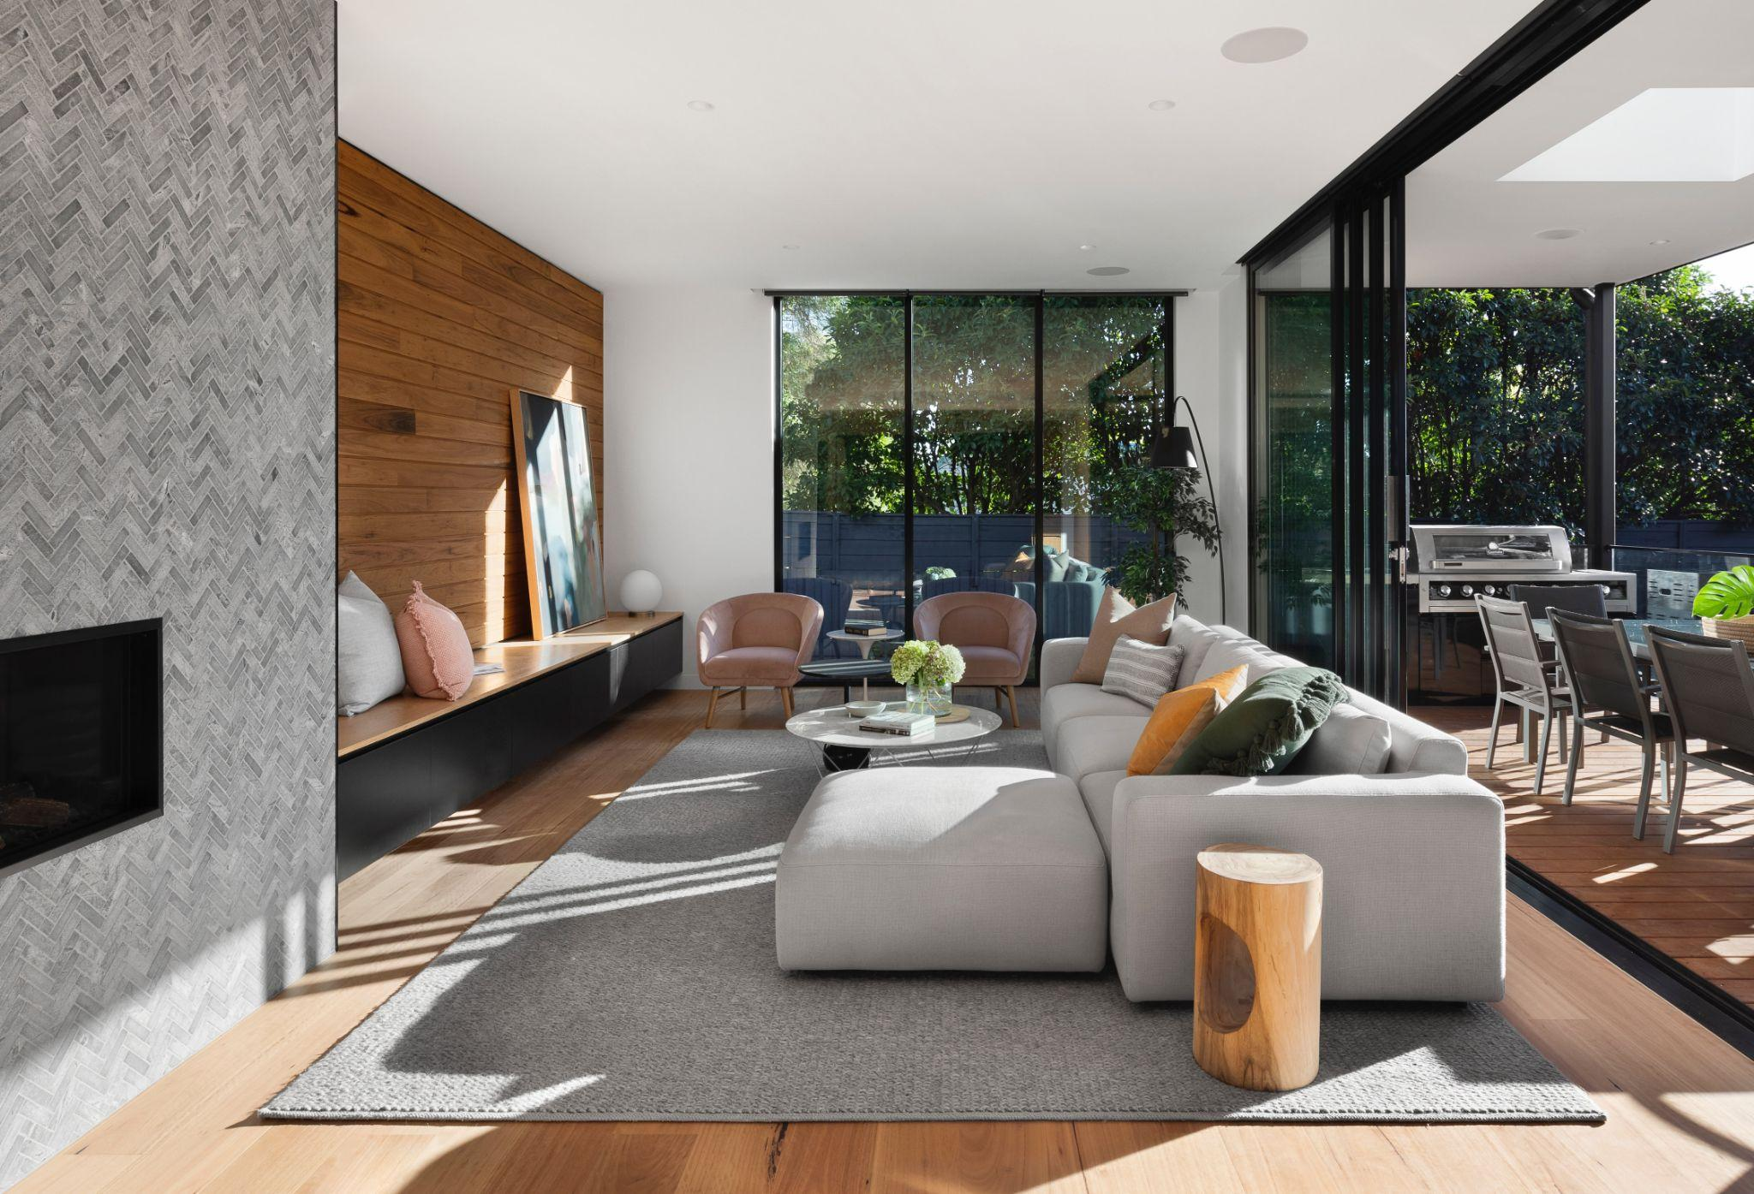

When leasing a property, ensuring its cleanliness is paramount. We offer meticulous sanitation services to enhance the appeal of leased properties and ensure they are in top condition for tenants.

* + **Post-Occupancy Cleanup**

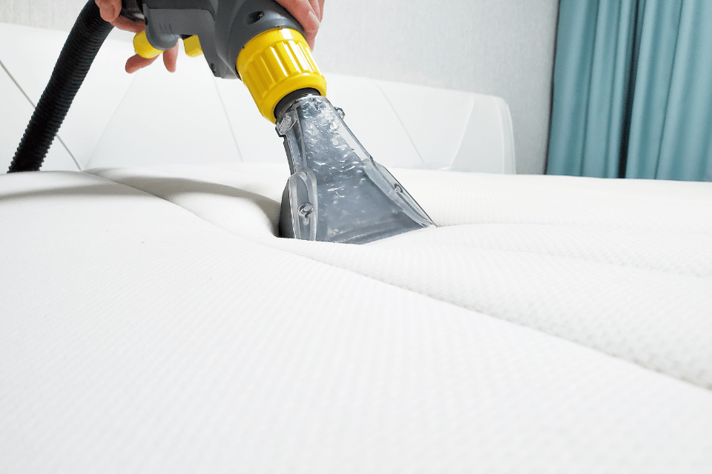

After tenants vacate, a thorough cleanup ensures the property is ready for its next occupants. Our post-occupancy cleanup rejuvenates spaces, making them feel as good as new.

* + **Pre-Occupancy Scrub-down and Inspection**

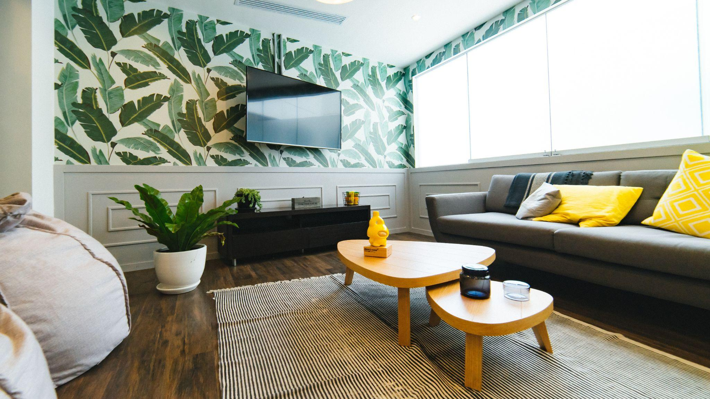

Before moving in, ensure your property is hygienic and spotless. We provide an intensive scrub-down and inspection service, ensuring every room and corner is in impeccable condition for new occupants.

* + **Cleaning Services before Property Sale**



First impressions matter when selling a property. Our cleaning services ensure that potential buyers are met with a gleaming, well-maintained space, significantly boosting its market appeal.

* + **Detailed Cleaning of Kitchens, Bathrooms, and Ovens**

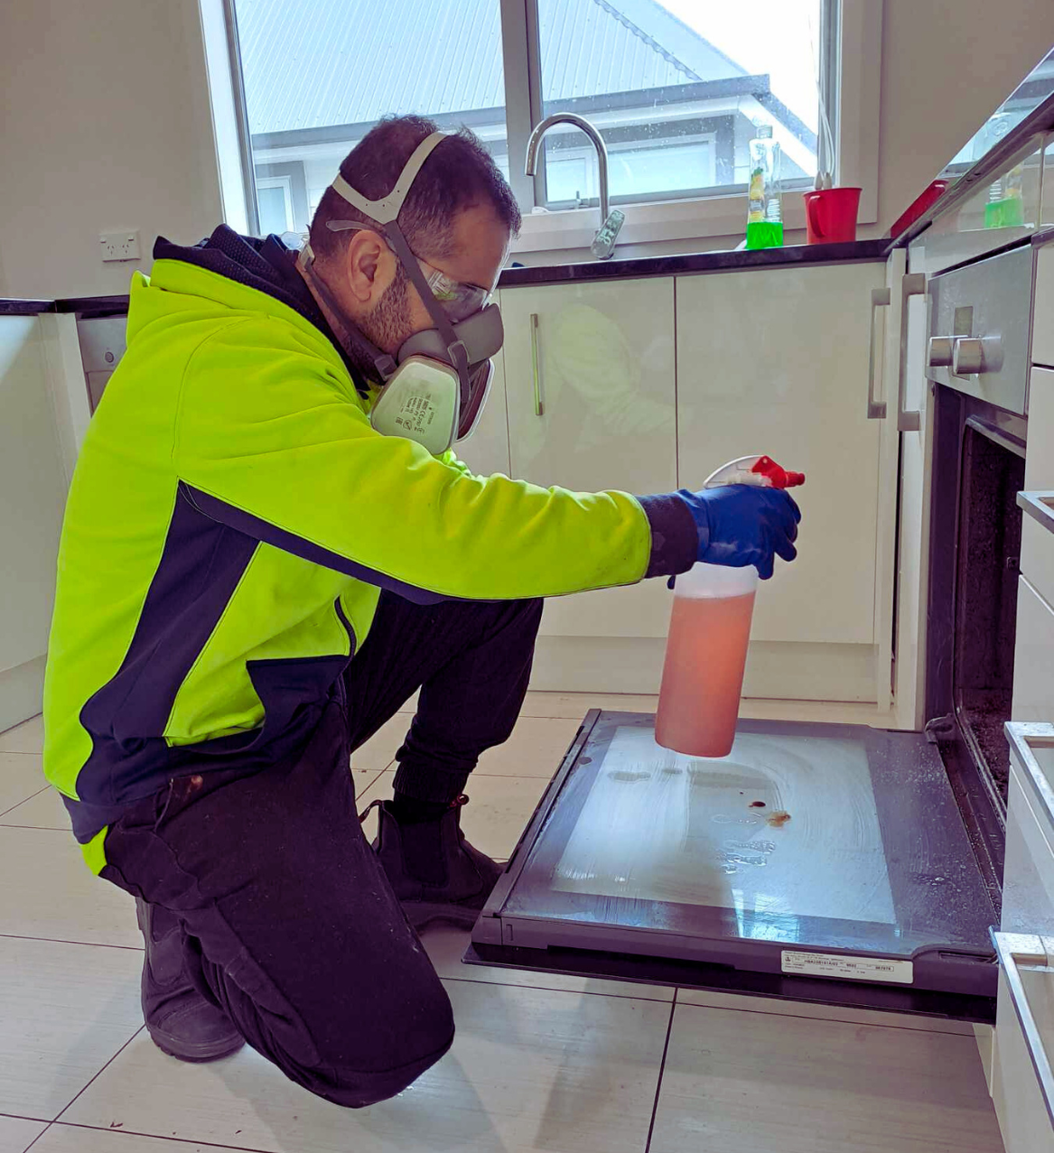

High-use areas like kitchens and bathrooms demand special attention. Our detailed cleaning targets grime, build-up, and spots in these areas, including deep-cleaning of ovens, ensuring they shine and function like brand new.

* + **Wall and Ceiling Cleaning**

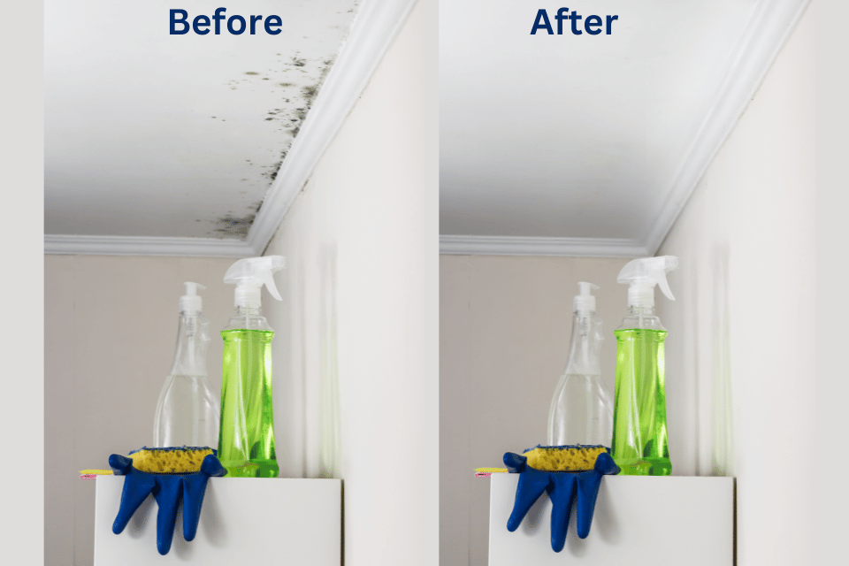

Over time, walls and ceilings collect dust, stains, and cobwebs. Our sanitation services revitalize these large surfaces, enhancing the overall cleanliness and air quality of the property.

* + **Mildew and Mould Remediation**

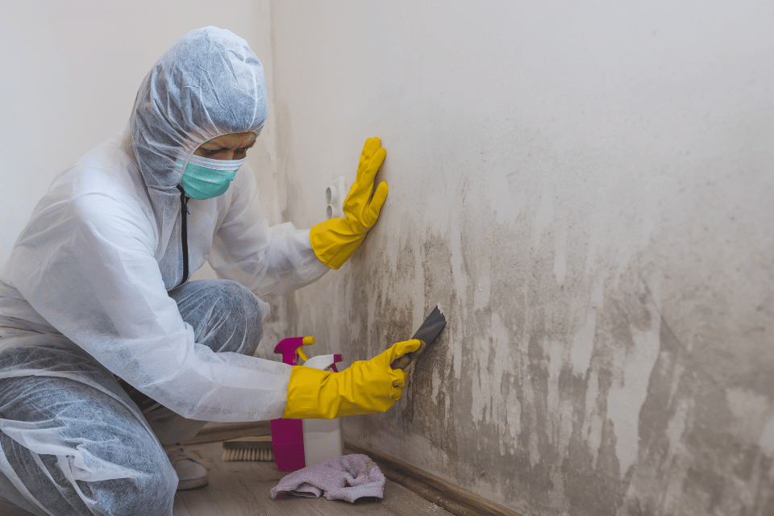

Mould and mildew can pose significant health risks. We specialize in their remediation, employing advanced techniques to thoroughly remove and prevent their return, ensuring a safer living environment.

* + **House, Deck, and Pathway Power Washing**

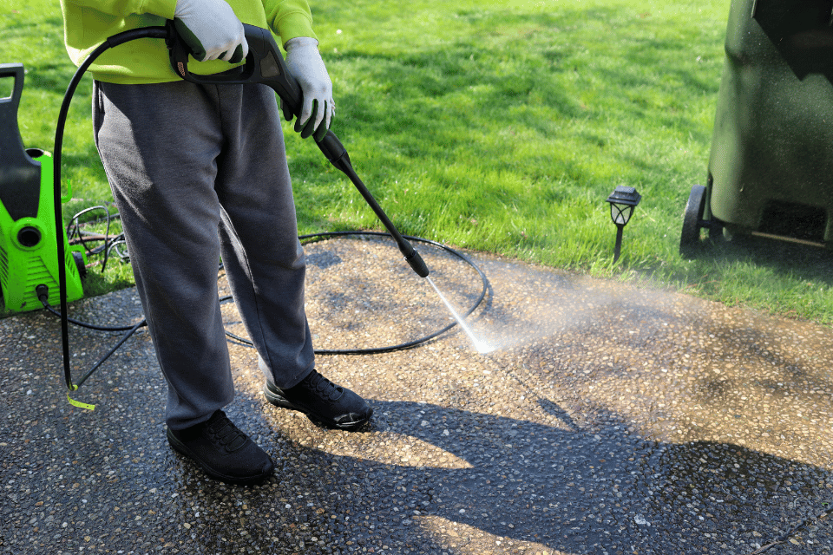

Exterior surfaces often bear the brunt of natural elements. Our power washing services strip away dirt, algae, and stains from houses, decks, and pathways, restoring their original beauty and prolonging their lifespan.

* + **Transparent Surface (Window) Cleanup**

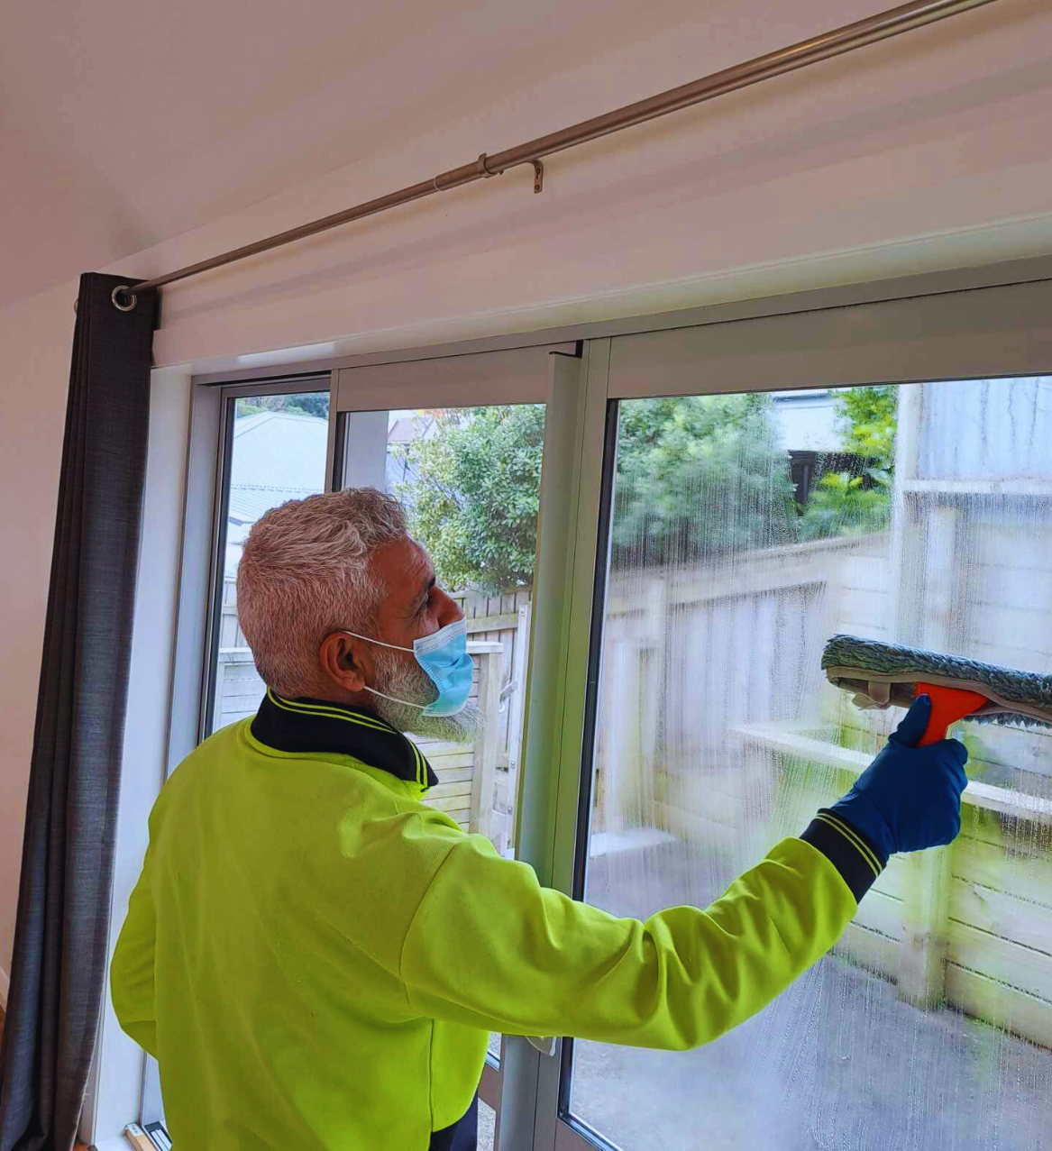

Clear windows elevate a property's aesthetic. We offer window cleanup services that remove dirt, streaks, and residues, ensuring sparkling clarity that enhances natural light and views.

* **Specialized Cleaning Solutions**
  + **Rug and Carpet Deep Clean**

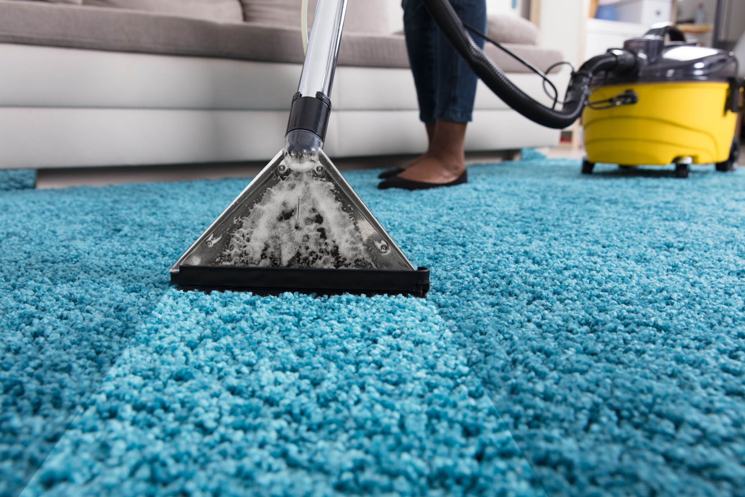

G'day to your carpets! At Cleanova, we give your rugs and carpets a thorough refresh, reaching deep into the fibres to lift out stubborn dirt and stains. Leave it to us, and we'll make sure your flooring looks and feels brand spanking new.

* + **Furniture Upholstery Freshening**

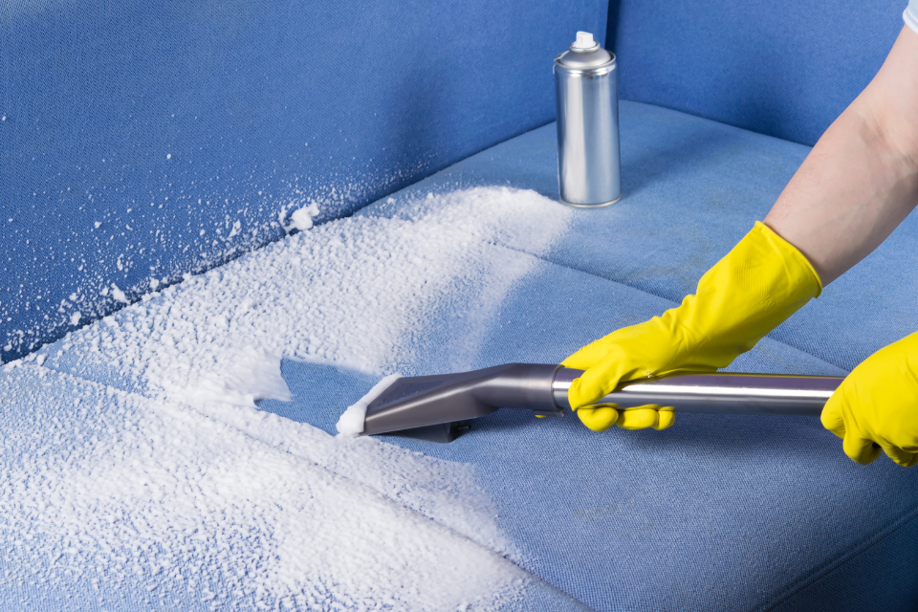

Dusty old couches? No worries! We breathe new life into your furniture, ensuring every lounge, chair, and sofa in your home gets a proper spruce up. With Cleanova, your furnishings will feel as refreshing as a cool breeze on a hot summer's day.

* + **Comprehensive Springtime Cleaning**

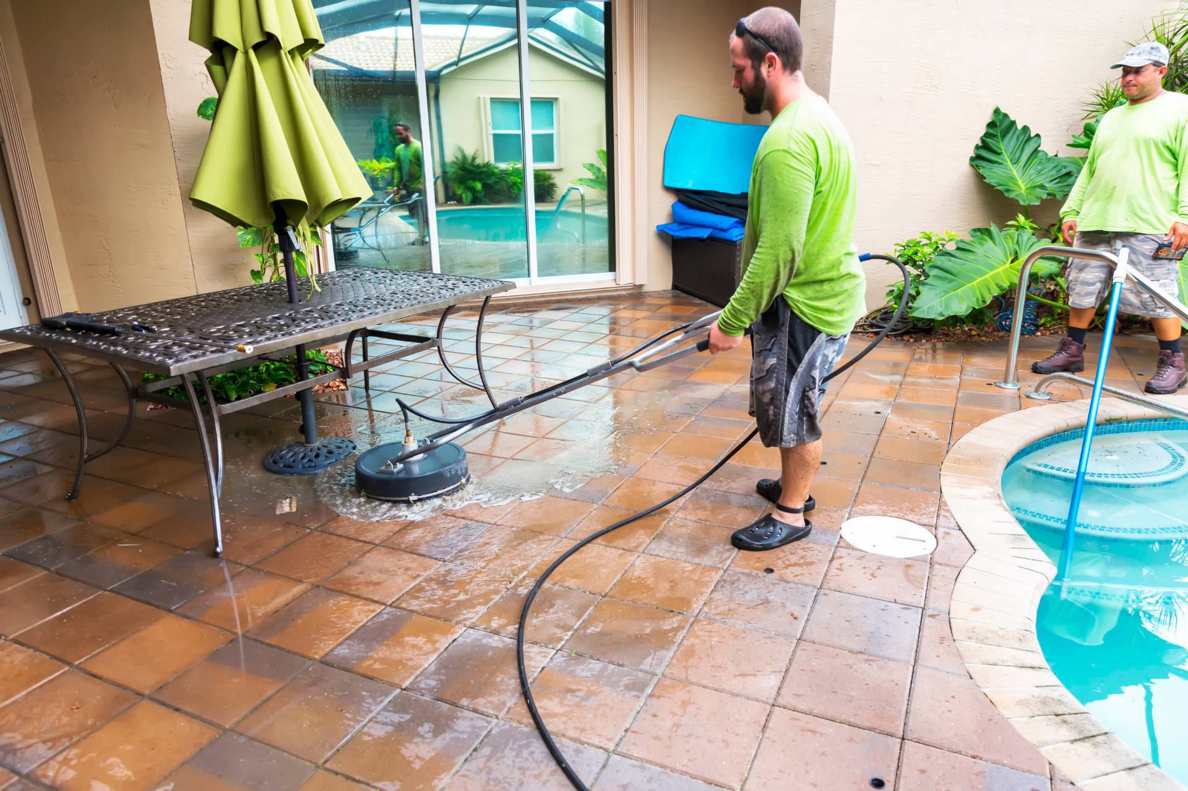

Spring in Oz means one thing - a proper clean-up! We tackle every nook and cranny, ensuring your home shines brighter than the Southern Cross. With our springtime cleaning, every corner of your space will feel rejuvenated and ready for the year ahead.

* + **In-Depth Sanitization and Sterilization**

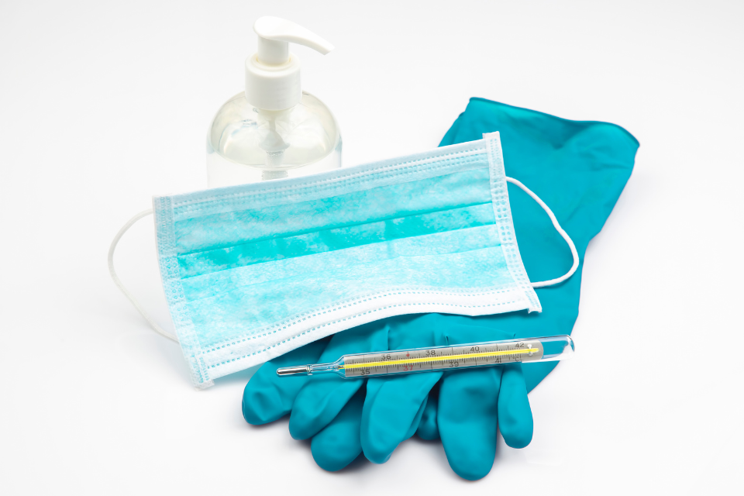

Keeping things clean as a whistle is essential, especially these days. Our team goes the extra mile, ensuring that germs and bacteria don't stand a chance. We're all about giving you that peace of mind in true blue style.

* + **Thorough Bathroom Scrub-down**

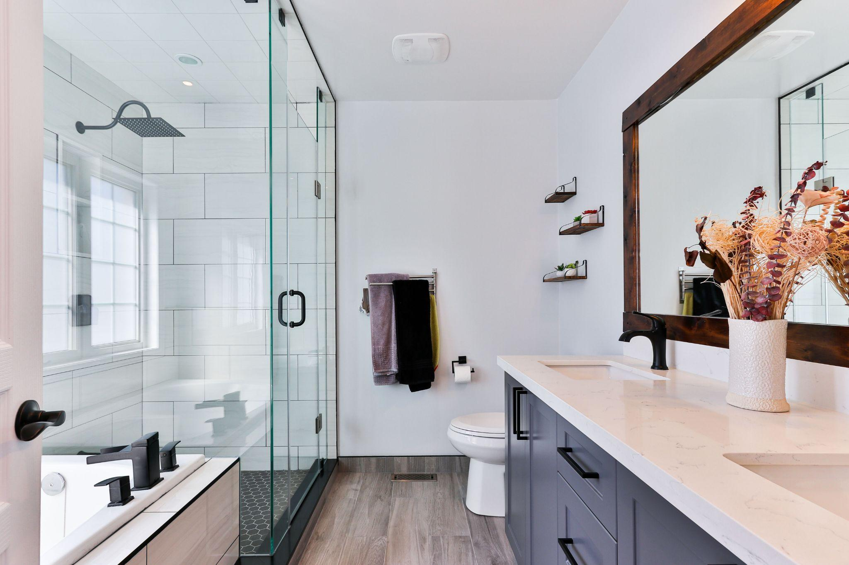

From the taps to the tiles, we give your bathroom the makeover it deserves. Say goodbye to soap scum and hello to a sparkling space. After we're done, your bathroom will shine brighter than the sun over Bondi Beach.

* **Additional Cleaning Services**
  + **Vehicle Interior & Exterior Cleaning**

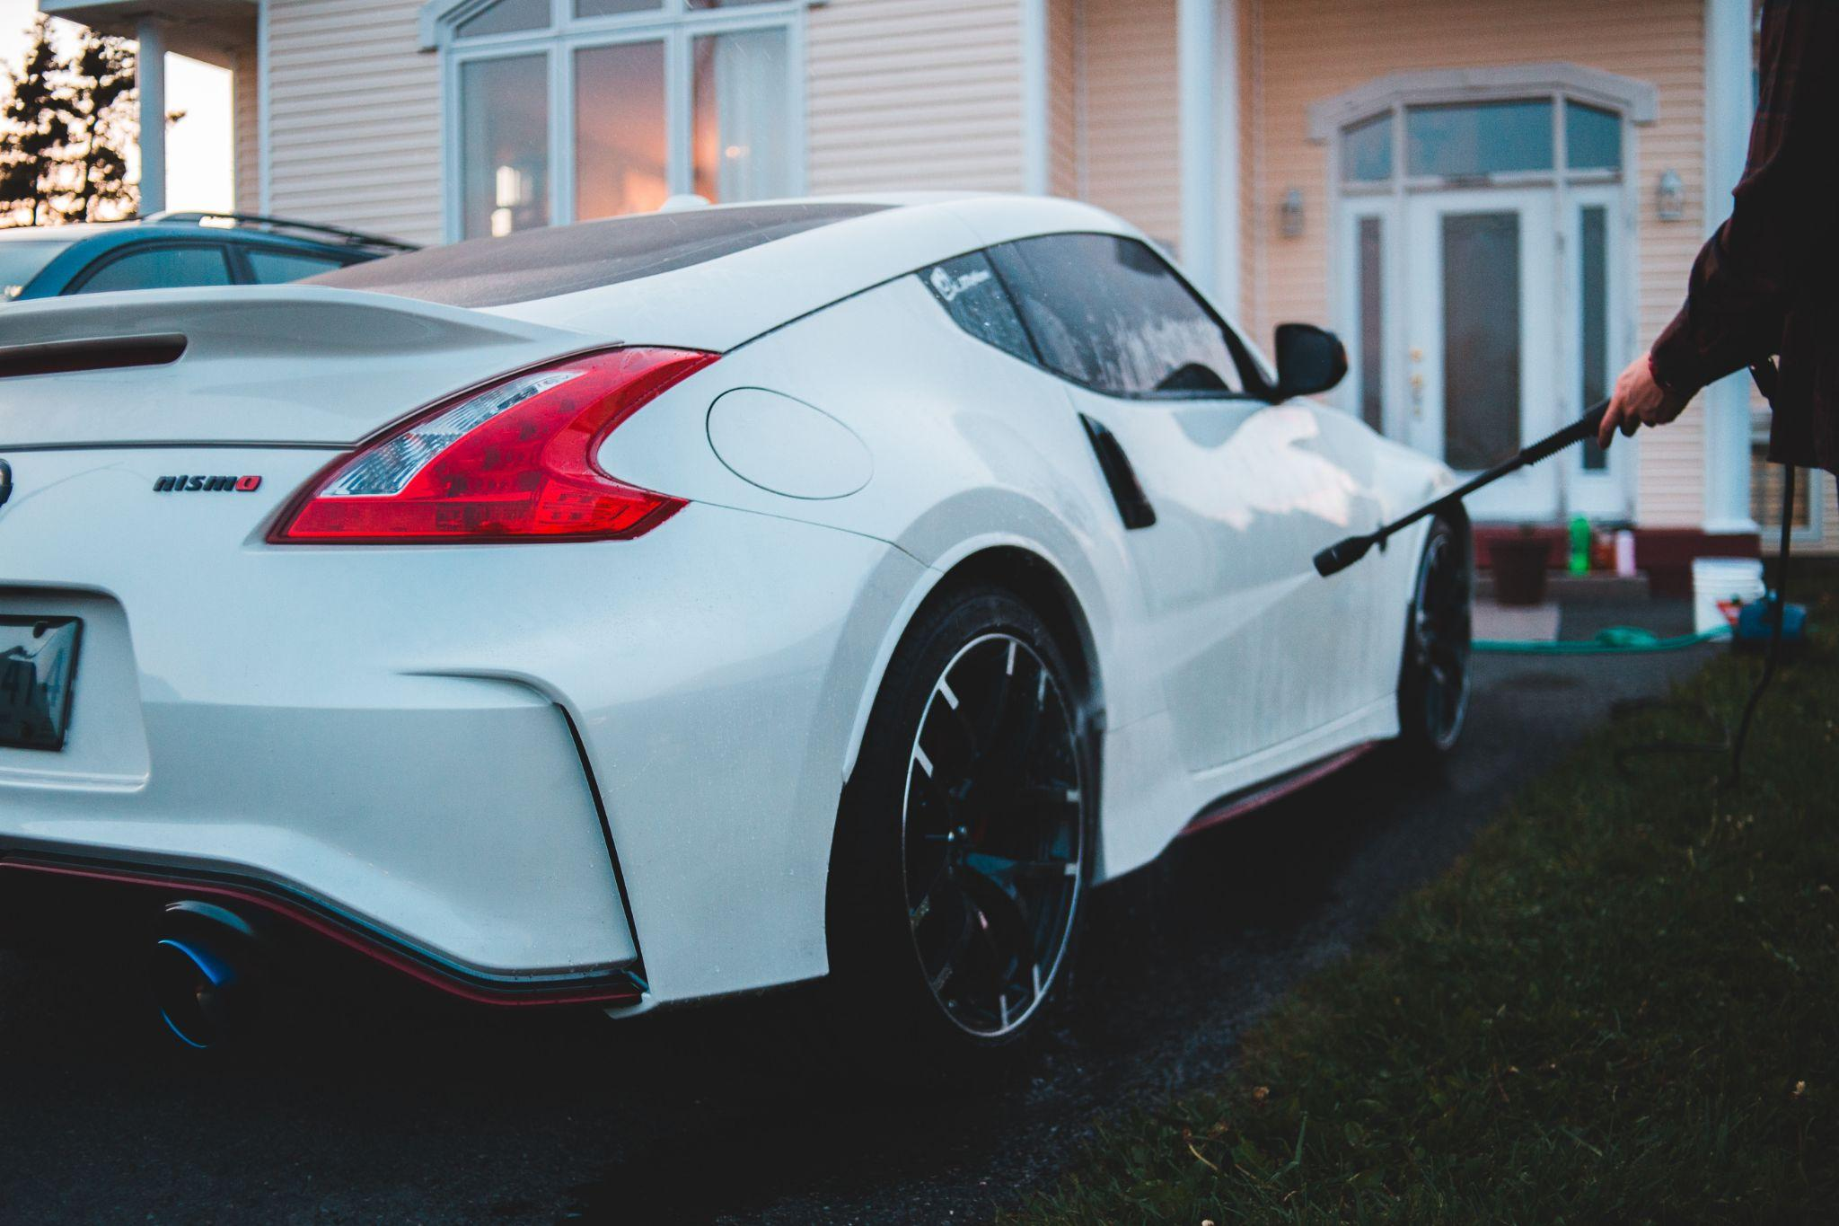

Hitting the road for a classic road trip? We make sure you're cruising in cleanliness. From dust-laden dashboards to crumby crevices, our team dives in to ensure your ride's interior is as stunning as our coastline. Next stop? A gleaming, grime-free car journey.

* + **Water Blasters**

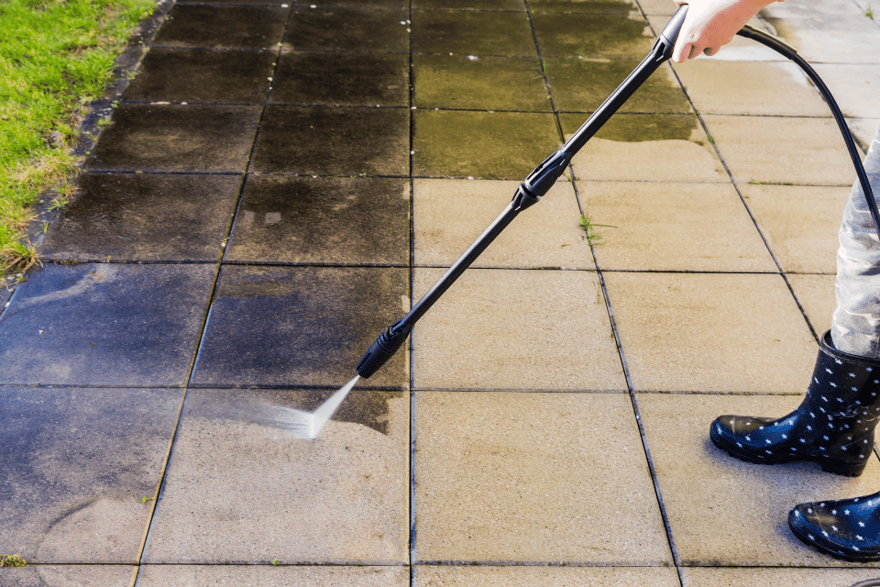

Tough stains and grime don't stand a chance against our high-pressure water blasters. Whether it's your driveway that's seen one too many barbies or walls stained by unpredictable weather, we tackle it all, leaving surfaces looking as pristine as the waters of the Whitsundays.

* + **Upholstery cleaning**

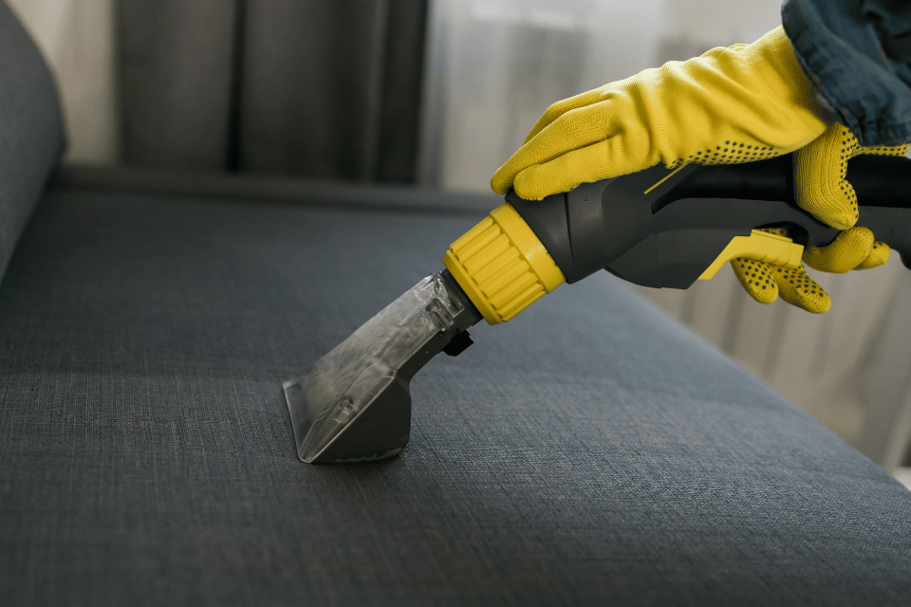

Your favourite armchair or family sofa deserves a touch of TLC. We delve deep into the fabric, eradicating dirt and refreshing your furnishings. Post-Cleanova treatment, your upholstery will feel as inviting as a warm evening by the campfire.

* + **Restoration Cleaning**

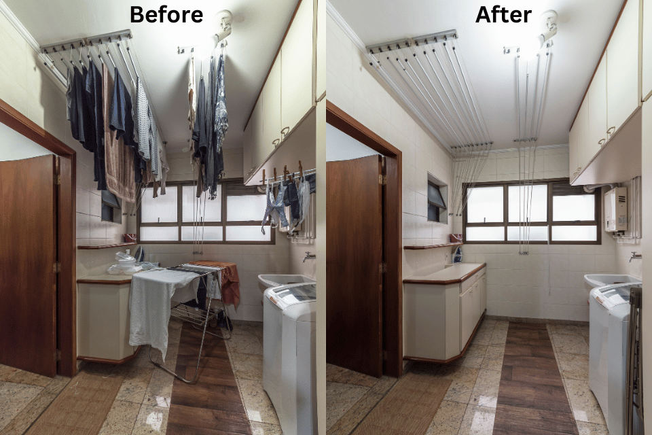

Got a space that's seen better days? Our restoration cleaning services are the ultimate facelift. Whether it's old estates or spaces tarnished by time, we renew and rejuvenate, ensuring every corner shines with its former glory, just like the golden sands at sunrise.

* + **Mattress cleaning**

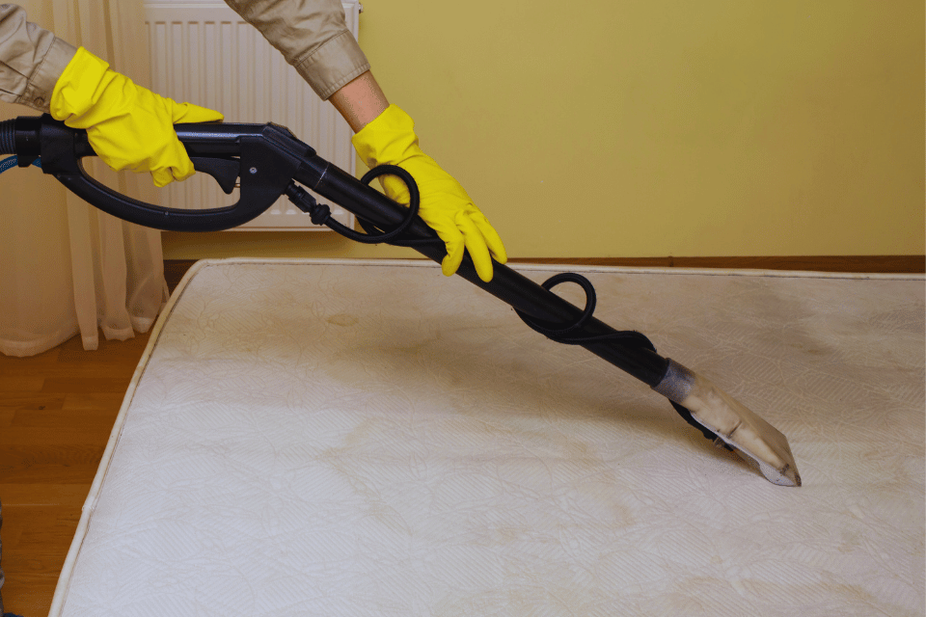

Sleep is essential, especially after a long day enjoying adventure. We ensure your bed is a sanctuary, diving deep into mattresses to remove dust mites and allergens. With Cleanova, you're set for a rest as peaceful as the Outback under a starry night.

